**Setting Up Internet Explorer to Run Siebel**

If you are unable to run Siebel via Internet Explorer (IE), please follow the steps below to update your IE settings so that Siebel can run on your computer.

1. **Install Siebel ActiveX controls on your computer.**

* Download [ActiveX_Plugin.zip](https://msit.comfortsite.com/Siebel/Installation/8.1.1.11_ActiveX_Plug_In/ActiveX_Plugin.zip) by clicking on the link.
* Save “ActiveX_Plugin.zip” to your desktop.
* Once ActiveX_Plugin.zip is saved to your desktop, right-click on the file and select “Extract All…”

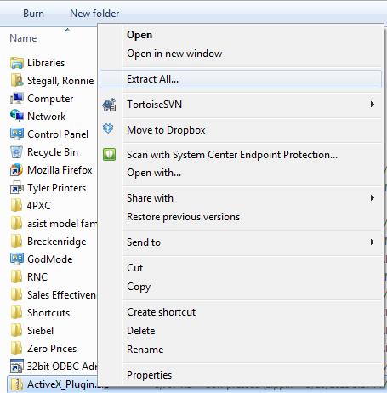

* Extract the file to your desktop.
* Navigate to the folder you extracted to. It is probably named ActiveX_Plugin.
* Right-click on “PredeployRs.EXE” and click “Run as administrator”.

**Please continue to next page.**

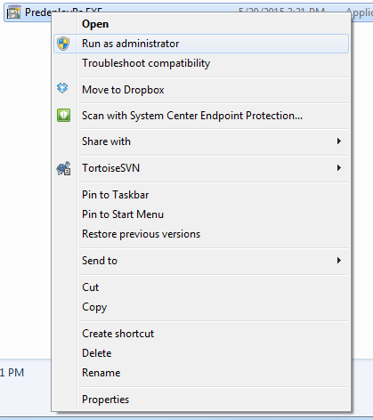

* After clicking “Run as administrator” a black window should open and the installation ActiveX control installation process should begin. Do not interrupt the process.
* Once the deployment is successful, the black window will close.

**Please continue to next page.**

1. **Validate that you are using the 32-bit version of Internet Explorer**

* Open Internet Explorer
* Click on Help
* Click About Internet Explorer
* Confirm that it does **not** say “64-bit Edition” next to the version of Internet Explorer. If it does say “64-bit Edition”, please reach out to your local IT administrator for help you locate the 32-bit version of Internet Explorer on your computer.

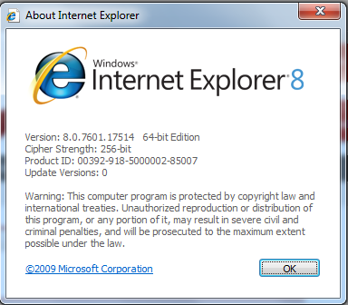

**Please continue to next page.**

1. **Add the Siebel URL to your “Trusted Sites”**

Select -- Tools

* Internet Options
* Security Tab
* Trusted Sites
* Click “Sites” button

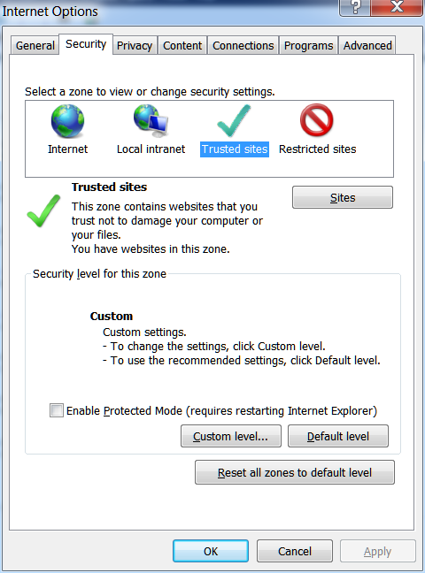

**Please continue to next page.**

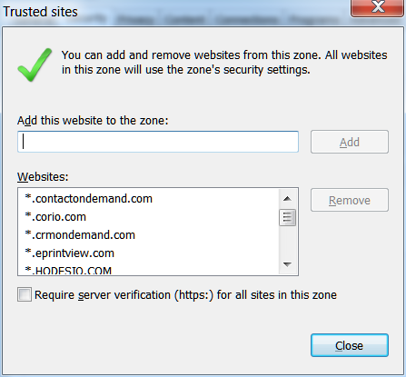

**Paste this in the add box:**

**http://rshvacsb**

**Require server verification must be unchecked to add**

Paste the URL below in the “Add this website to the zone:” box.

<http://rshvacsb>

Click Add, check the “Require server verification (https:) for all sites in this zone” checkbox, and then Close.

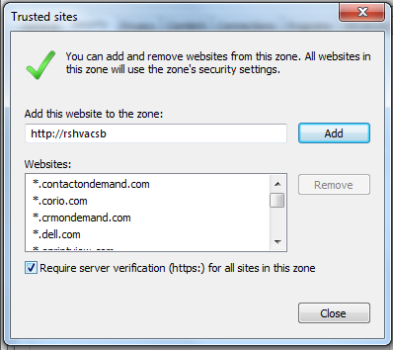

**Be Sure to check box after adding**

Close Last

ADD

1. **Add the Siebel URL to Compatibility View Settings**

Select --Tools

* Compatibility View Settings
* Paste <http://rshvacsb> in the “Add this website:” box.
* Click Add
* Make sure the “Display all websites in Compatibility View” checkbox is checked.
* Click Close

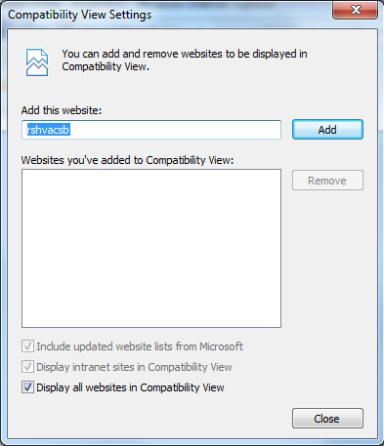

Select Close

Make sure this box is Checked

**Please continue to next page.**

1. **Allow your computer to Download the Active X Plug-in**

* Click on Tools 🡪 Internet Options and Choose Trusted Sites
* Click “Custom Level” button

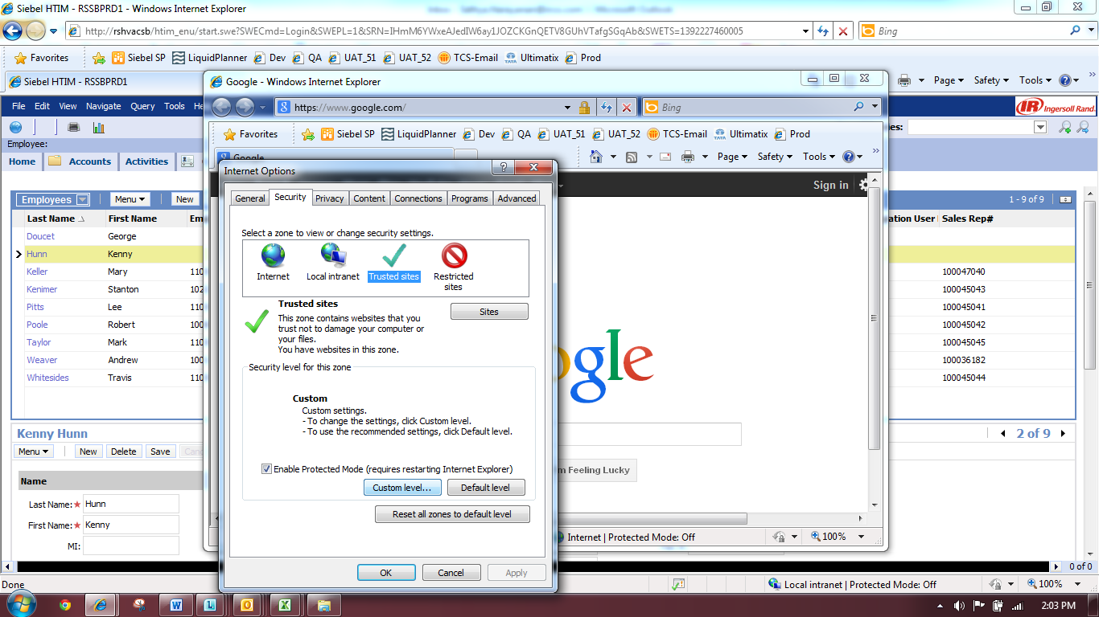

* After clicking the “Custom level…” button you will see the screenshot below.

**Please continue to next page.**

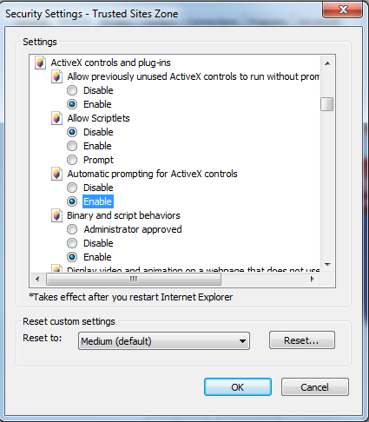

* Please make sure that the “ActiveX controls and plug-ins” options are set as per table below.

|  |  |  |
| --- | --- | --- |
| **Section** | **Setting Name** | **Setting** |
| ActiveX controls and plug-ins | Allow previously unused ActiveX controls to run without prompt | Enable |
| ActiveX controls and plug-ins | Automatic prompting for ActiveX controls | Enable |
| **ActiveX controls and plug-ins** | **Download signed ActiveX controls** | **Enable** |
| **ActiveX controls and plug-ins** | **Download unsigned ActiveX controls** | **Enable** |
| ActiveX controls and plug-ins | Initialize and script ActiveX controls not marked as safe for scripting | Enable |
| ActiveX controls and plug-ins | Only allow approved domains to use ActiveX without prompt *(please note that this setting is not available in Internet Explorer 7)* | Disable |
| ActiveX controls and plug-ins | Run ActiveX controls and plug-ins | Enable |
| ActiveX controls and plug-ins | Script ActiveX controls marked safe for scripting | Enable |

**\*\* Note: After successfully logging into Siebel, set the options in red text above back to their original values.**

* After setting the “ActiveX controls and plug-ins” options as shown above, click “OK”, and then “OK” again on the Security tab.
* Close all Internet Explorer windows and then reopen Internet Explorer and navigate to Siebel.
* Attempt to log into Siebel. If you are able to successfully log into Siebel and navigate around the application, you can stop here. If you are still having issues accessing Siebel, please proceed to the next step.

1. **Validate Internet Explorer Advanced Settings**

Select

* + Tools
  + Internet Options
  + Advanced Tab

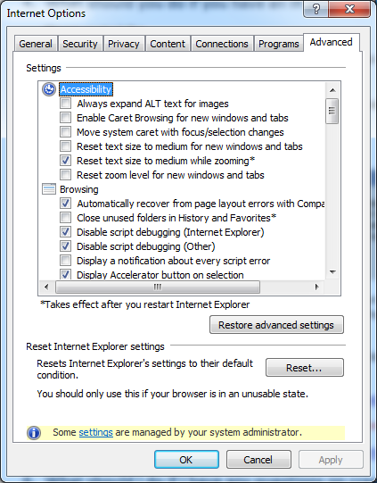

Please make sure that the options are set as per table below.

|  |  |  |
| --- | --- | --- |
| **Section** | **Setting Name** | **Setting** |
| Browsing | Disable Script debugging (Internet Explorer) | Checked |
| Browsing | Disable Script debugging (Other) | Checked |
| Browsing | Display a notification about every script error | Unchecked |
| Browsing | Enable third-party browser extensions | Unchecked |
| Browsing | Enable visual styles on buttons and controls in webpages | Unchecked |
| Browsing | Show friendly HTTP error messages | Unchecked |
| Browsing | Use Passive FTP (for firewall and DSL modem capability) | Unchecked |
| HTTP 1.1 settings | Use HTTP 1.1 | Checked |
| HTTP 1.1 settings | Use HTTP 1.1 through proxy connections | Checked |
| International | Send UTF-8 URL’s | Checked |
| Java (Sun) | Use JRE *X.Y.Z_nn* for <applet> (requires restart) | Checked |
| Multimedia | Show image download placeholders | Checked |
| Multimedia | Show pictures | Checked |
| Multimedia | Smart image dithering | Checked |
| Printing | Print background colors and images | Checked |
| Security | Check for publisher’s certificate revocation | Unchecked |
| Security | Check for signatures on downloaded programs | Checked |
| Security | Empty Temporary Internet Files folder when browser is closed | Unchecked |
| Security | Enable memory protection to help mitigate online attacks *(please note that this setting is not available in Internet Explorer 7)* | Unchecked |
| Security | Warn if changing between secure and not secure mode | Unchecked |

* Click “Apply” and “OK”.

1. **Validate Internet Explorer Security Settings**

Select

* + Tools
  + Internet Options
  + Security Tab
  + Trusted Sites

Click the “Custom Level…” button

**Please continue to next page.**

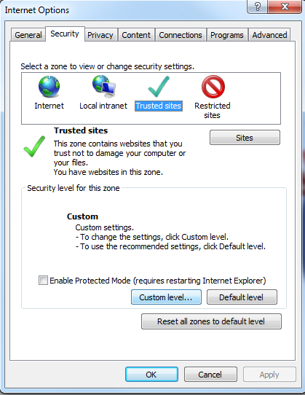

Please make sure that the options are set as per table below.

|  |  |  |
| --- | --- | --- |
| * **Section** | **Setting Name** | **Setting** |
| Downloads | File download | Enable |
| Miscellaneous | Access data sources across domains | Enable |
| Miscellaneous | Allow META REFRESH | Disable |
| Miscellaneous | Allow script-initiated windows without size or position constraints | Enable |
| Miscellaneous | Allow webpages to use restricted protocols for active content | Enable |
| Miscellaneous | Allow websites to open windows without address or status bars | Enable |
| Miscellaneous | Display mixed content | Enable |
| Miscellaneous | Don’t prompt for client certificate selection when no certificates or only one certificate exists | Enable |
| Miscellaneous | Launching programs and files in an IFRAME | Enable |
| Miscellaneous | Navigate windows and frames across different domains | Enable |
| Miscellaneous | Use Pop-up Blocker | Disable |
| Scripting | Active scripting | Enable |
| Scripting | Allow status bar updates via script | Enable |
| Scripting | Allow websites to prompt for information using scripted windows | Enable |
| Scripting | Scripting of Java applets | Enable |

* After setting the options as shown above, click “OK”, and then “OK” again on the Security tab.
* Close all Internet Explorer windows and then reopen Internet Explorer and navigate to Siebel.

Attempt to log into Siebel. If you are still having issues accessing Siebel, please call the IR helpdesk **1-800-872-6381** and create a ticket. The RS HVAC Siebel Support team needs a ticket to look into your issue and help you better. Give the details below to them to get the ticket created and routed to the correct technical team.

* Provide the Product as: **RS HVAC SIEBEL**
* Issue Description (Please provide Quote #, screenshot or error message, Customer # etc.)
* Your Siebel Id, Full Name, Contact Phone # and email or if you are raising a ticket on behalf of someone, then provide the details for that person
* Mention to the helpdesk person that the ticket should be escalated to the **RS-HVAC-SIEBEL** support group.
* Finally after creating the ticket, email the ticket #  to [rs-hvac-siebel-support@irco.com](mailto:rs-hvac-siebel-support@irco.com)