Here is Link to log in with your password and ID

<https://rshvacsb.ingersollrand.com/htimex_enu/start.swe>

**Adding the Siebel URL to your trusted sites**

Select -- Tools

* Internet Options
* Security Tab
* Sites

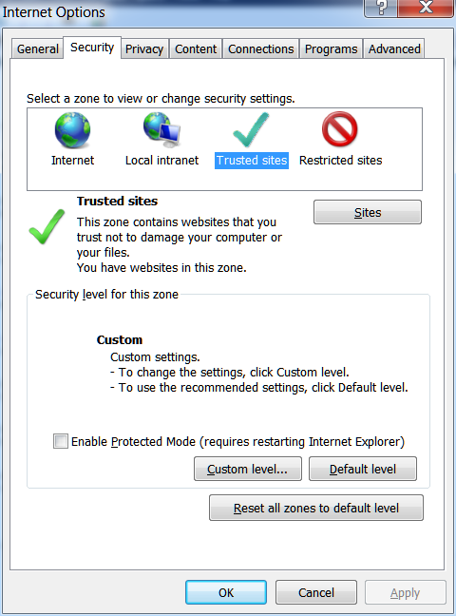

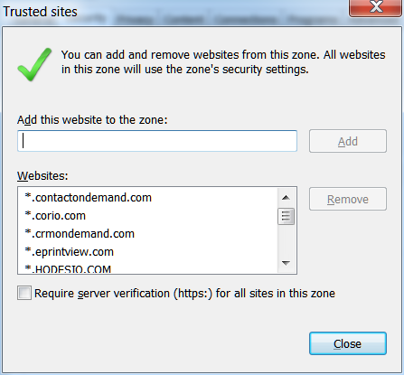

**This box should be checked**

**https://** r**shvacsb.ingersollrand.com /htimex_enu/start.swe Paste this in the add box**

<https://rshvacsb.ingersollrand.com/htimex_enu/start.swe>

Paste this in the add box

The required Server verification (https) for all sites in this zone will need to be “checked” to add

Click Add

Please make sure when you save this path it only has this <https://rshvacsb.ingersollrand.com/htimex_enu/start.swe> in the box

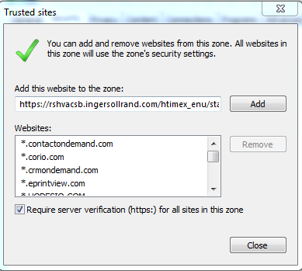

Close Last

ADD

**Compatibility View Settings**

**Setting Compatibility View Settings**

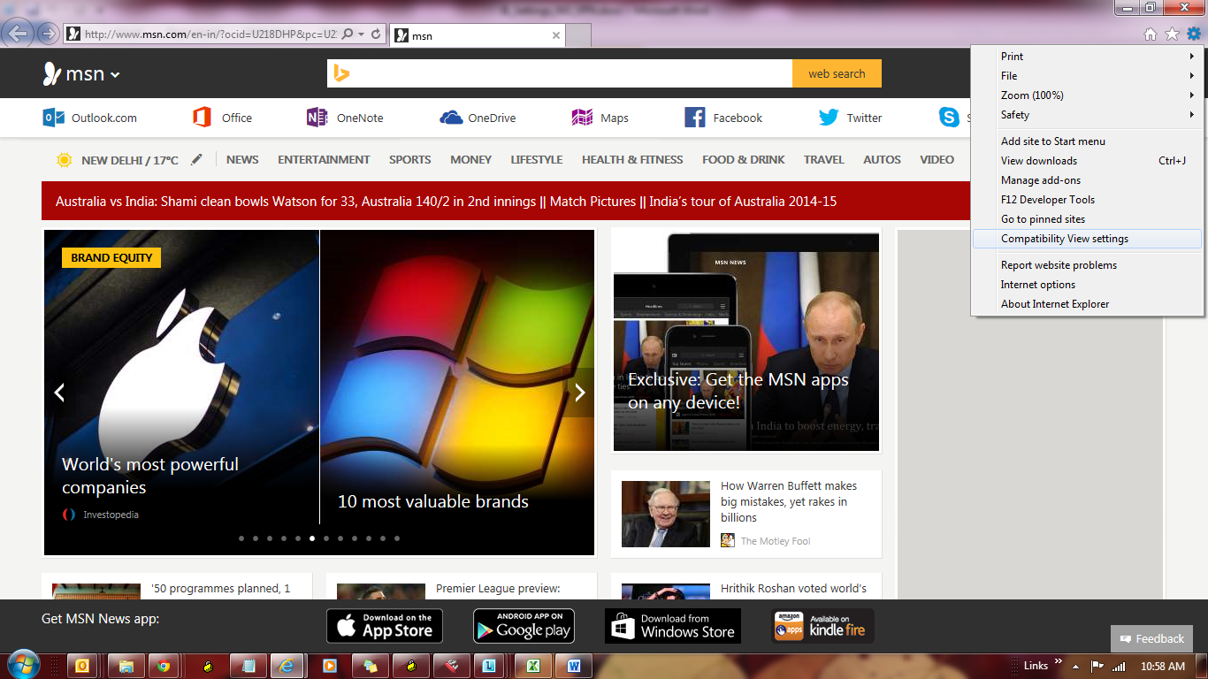

Select --Tools

* + Compatibility View Settings
  + make sure the last box is Checked

(Display all websites in Compatibility View)

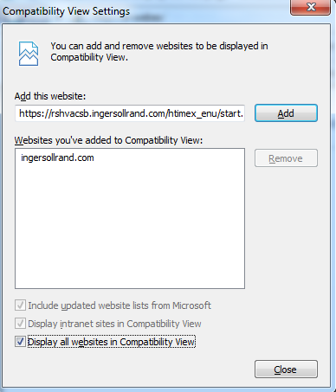

Select Close

Make sure this box is Checked

**Allowing your computer to Download the Active X Plug-in**

* Click on Tools 🡪 Internet Options and Choose Trusted Sites
* Select Custom Level… button

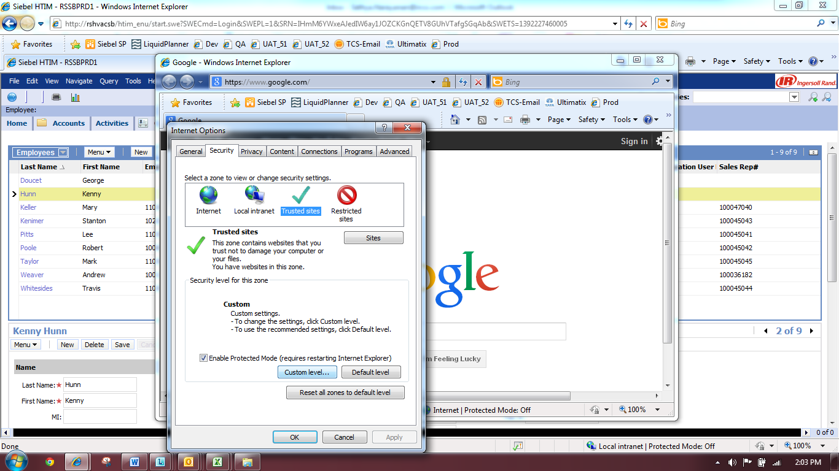

Look for any option that has the word “Active-X” in it. If you see one, then please set it to Enable or Prompt. Examples given below .. (If you have Enable, Disable and Prompt.. then choose Prompt). This should let the Active X to be downloaded to your system.

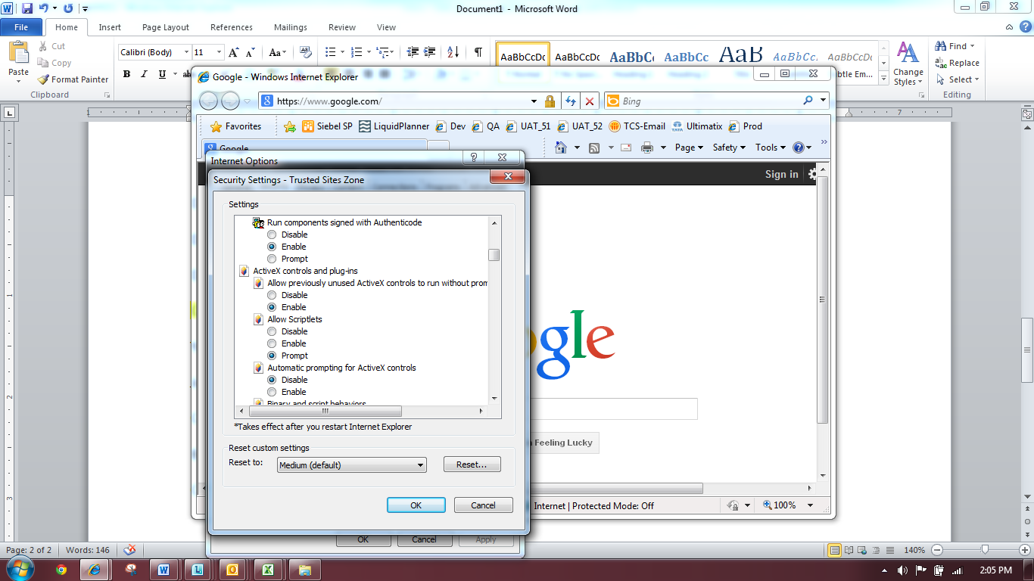

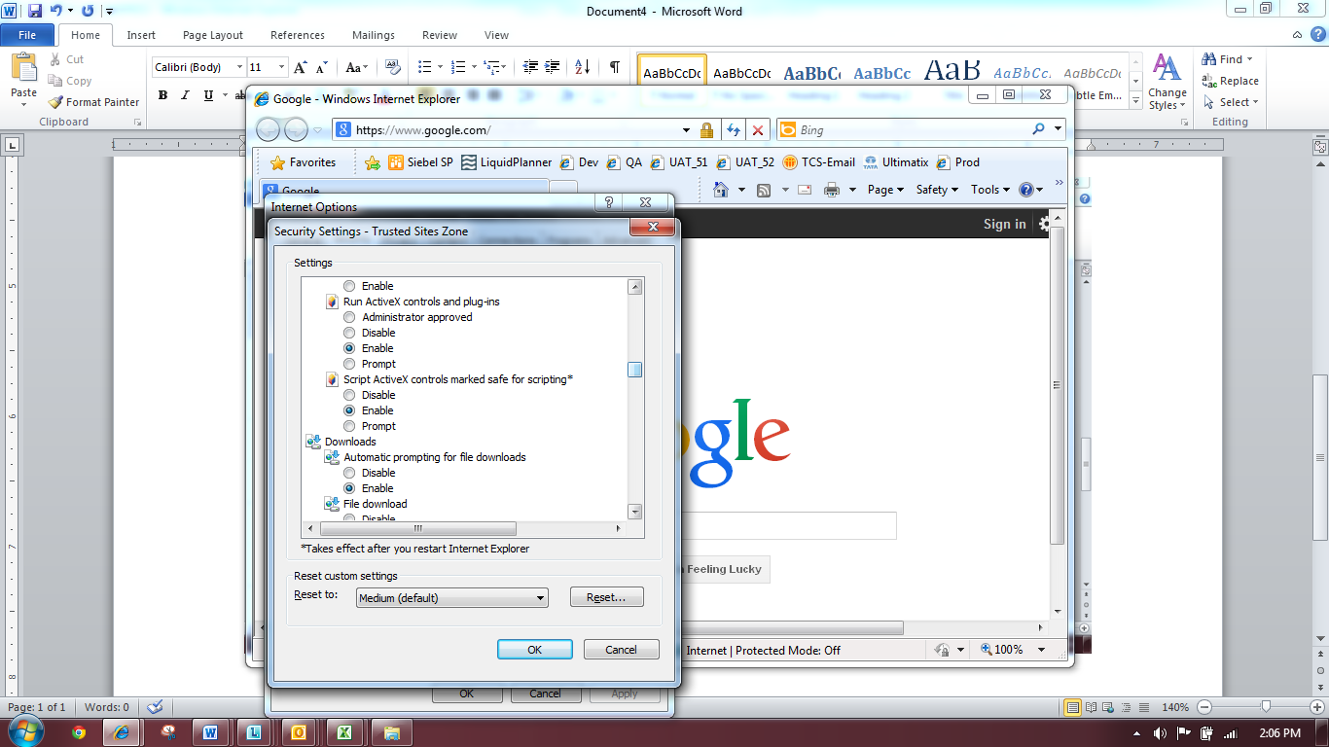

**Create a Short Cut to your webpage**

<https://rshvacsb.ingersollrand.com/htimex_enu/start.swe>

Select - Favorites

--Add to Favorites Bar

If name Siebel does not show up

Right click on the name and choose rename

This is your Favorite Bar

Right click to rename

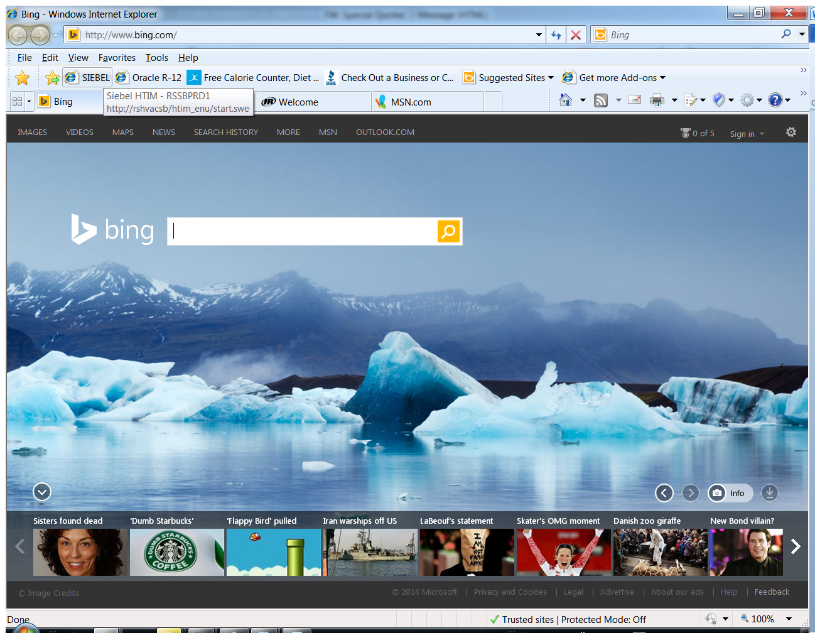

IF you need to open Two copies of Siebel

You have to Select File Then select; New Session **You can only have two sessions open at a time**

* File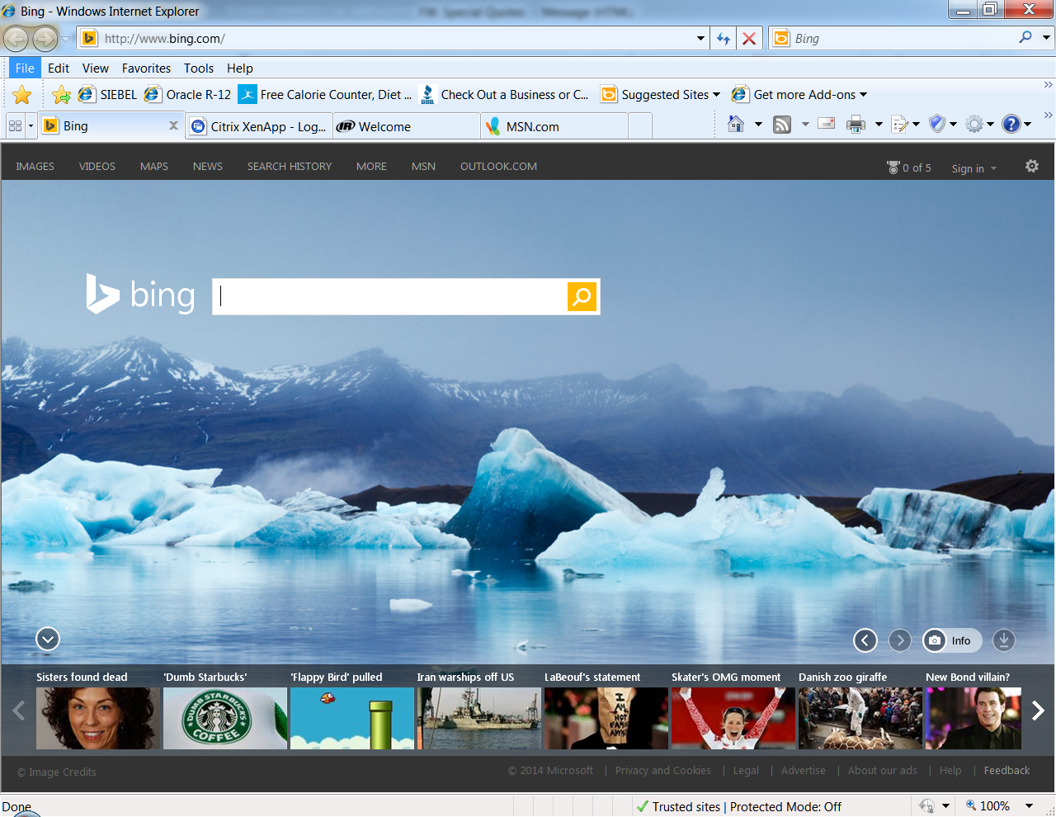

File

Then Select

New Session

Click on this link download the file. Run the same (it is safe to run the file) Before you run the file, make sure all above changes are done

<https://msit.comfortsite.com/siebel/installation/RsHvacSiebel-NoVPN.msi>

If Issue related to Siebel High Interactivity Framework for IE still Exist:

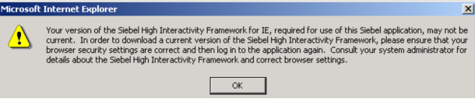

Select

* + Tools
  + Internet Options
  + Advanced Tab

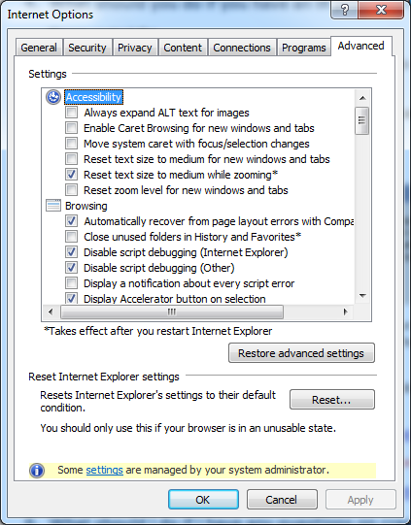

Please Make Sure that Options are Checked/Unchecked as per below table.

|  |  |  |
| --- | --- | --- |
| **Section** | **Setting Name** | **Setting** |
| Browsing | Disable Script debugging (Internet Explorer) | Checked |
| Browsing | Disable Script debugging (Other) | Checked |
| Browsing | Display a notification about every script error | Unchecked |
| Browsing | Enable third-party browser extensions | Unchecked |
| Browsing | Enable visual styles on buttons and controls in webpages | Unchecked |
| Browsing | Show friendly HTTP error messages | Unchecked |
| Browsing | Use Passive FTP (for firewall and DSL modem capability) | Unchecked |
| HTTP 1.1 settings | Use HTTP 1.1 | Checked |
| HTTP 1.1 settings | Use HTTP 1.1 through proxy connections | Checked |
| International | Send UTF-8 URL’s | Checked |
| Java (Sun) | Use JRE *X.Y.Z_nn* for <applet> (requires restart) | Checked |
| Multimedia | Show image download placeholders | Checked |
| Multimedia | Show pictures | Checked |
| Multimedia | Smart image dithering | Checked |
| Printing | Print background colors and images | Checked |
| Security | Check for publisher’s certificate revocation | Unchecked |
| Security | Check for signatures on downloaded programs | Checked |
| Security | Empty Temporary Internet Files folder when browser is closed | Unchecked |
| Security | Enable memory protection to help mitigate online attacks *(please note that this setting is not available in Internet Explorer 7)* | Unchecked |
| Security | Warn if changing between secure and not secure mode | Unchecked |

Click on Tools 🡪 Internet Options and Choose Trusted Sites

Select Custom Level… button



Please Make Sure that Options are Checked/Unchecked as per below table.

|  |  |  |
| --- | --- | --- |
| **Section** | **Setting Name** | **Setting** |
| ActiveX controls and plug-ins | Allow previously unused ActiveX controls to run without prompt | Enable |
| ActiveX controls and plug-ins | Automatic prompting for ActiveX controls | Enable |
| ActiveX controls and plug-ins | Download signed ActiveX controls | Enable |
| ActiveX controls and plug-ins | Download unsigned ActiveX controls | Enable |
| ActiveX controls and plug-ins | Initialize and script ActiveX controls not marked as safe for scripting | Enable |
| ActiveX controls and plug-ins | Only allow approved domains to use ActiveX without prompt *(please note that this setting is not available in Internet Explorer 7)* | Disable |
| ActiveX controls and plug-ins | Run ActiveX controls and plug-ins | Enable |
| ActiveX controls and plug-ins | Script ActiveX controls marked safe for scripting | Enable |
| Downloads | File download | Enable |
| Miscellaneous | Access data sources across domains | Enable |
| Miscellaneous | Allow META REFRESH | Disable |
| Miscellaneous | Allow script-initiated windows without size or position constraints | Enable |
| Miscellaneous | Allow webpages to use restricted protocols for active content | Enable |
| Miscellaneous | Allow websites to open windows without address or status bars | Enable |
| Miscellaneous | Display mixed content | Enable |
| Miscellaneous | Don’t prompt for client certificate selection when no certificates or only one certificate exists | Enable |
| Miscellaneous | Launching programs and files in an IFRAME | Enable |
| Miscellaneous | Navigate windows and frames across different domains | Enable |
| Miscellaneous | Use Pop-up Blocker | Disable |
| Scripting | Active scripting | Enable |
| Scripting | Allow status bar updates via script | Enable |
| Scripting | Allow websites to prompt for information using scripted windows | Enable |
| Scripting | Scripting of Java applets | Enable |